Question Types

[Open ended question]

[Text]

**Q1. Name**:

Click or tap here to enter text.

[With validation mask]

**Q2. Email:**

__________________@____________._____

[Numeric, Integer]

**Q2. Age:**

*Valid values 1 – 120*

*Put 999 if do not know*

|_|_|_| years

[Numeric, decimal point]

**Q3. Height:**

|_|_|_|.|_|_|cm

[Multiline Text]

**Q4. Your opinion on NBS website:**

______________________________________________________________________________________________________________________________________________________________________________________________________________________________________________________

[Close ended questions]

[Single Select]

**Q5. Gender:**

1. Female
2. Male

[Single select, large list of answers]

**Q5.1 Country:**

* Choose an item.

[Multiple select]

**Q6. Languages spoken:**

*Choose all that apply*

1. Romanian
2. Russian
3. English
4. Italian
5. Other

[Rating]

**Q7. Rate NBS website:**

*1 Very bad – 5 Very good*

|  |  |  |  |  |
| --- | --- | --- | --- | --- |
| 1 | 2 | 3 | 4 | 5 |

[Boolean]

**Q8. Have you ever made a request for data to NBS?**

1. No
2. Yes

[Ranking]

**Q8. Sort from most important (5) to less important (1)**

1. Data are published on time ___
2. Data are published without errors ___
3. Published data includes methodology explanations ___
4. Published data can be found also in the statistical database ___
5. Published data includes a press release ___

[Open response option]

[Single Select]

**Q9. Nationality:**

1. Moldavian
2. Romanian
3. Russian
4. Do not know
5. Refuse to answer
6. Other 🡪 Specify ________________________________

[Multiple select]

**Q10. Languages spoken (choose all that apply):**

1. Romanian
2. Russian
3. English
4. Italian
5. Other 🡪 Specify _________________________________

[Matrix questions]

**Q11. Matrix**

|  |  |  |  |  |  |
| --- | --- | --- | --- | --- | --- |
|  | **Strongly Disagree** | **Disagree** | **Neutral** | **Agree** | **Strongly Agree** |
| **NBS website is user friendly** |  |  |  |  |  |
| **Statistical Database is very useful** |  |  |  |  |  |
| **NBS is a good source of official data** |  |  |  |  |  |
| **Electronic data are better than paper data** |  |  |  |  |  |

[Roster]

**Q12. Family Members:**

|  |  |  |  |  |  |
| --- | --- | --- | --- | --- | --- |
| **No** | **Name** | **Gender** | **Age** | **Email** | **Relationship[1]** |
| 1 |  | Male Female | |  |  |  | | --- | --- | --- | |  |  |  | | _______@_____.___ | |  | | --- | |  | |
| 2 |  | Male Female | |  |  |  | | --- | --- | --- | |  |  |  | | _______@_____.___ | |  | | --- | |  | |
| 3 |  | Male Female | |  |  |  | | --- | --- | --- | |  |  |  | | _______@_____.___ | |  | | --- | |  | |
| 4 |  | Male Female | |  |  |  | | --- | --- | --- | |  |  |  | | _______@_____.___ | |  | | --- | |  | |
| 5 |  | Male Female | |  |  |  | | --- | --- | --- | |  |  |  | | _______@_____.___ | |  | | --- | |  | |
| 6 |  | Male Female | |  |  |  | | --- | --- | --- | |  |  |  | | _______@_____.___ | |  | | --- | |  | |
| 7 |  | Male Female | |  |  |  | | --- | --- | --- | |  |  |  | | _______@_____.___ | |  | | --- | |  | |
| 8 |  | Male Female | |  |  |  | | --- | --- | --- | |  |  |  | | _______@_____.___ | |  | | --- | |  | |
| 9 |  | Male Female | |  |  |  | | --- | --- | --- | |  |  |  | | _______@_____.___ | |  | | --- | |  | |
| 10 |  | Male Female | |  |  |  | | --- | --- | --- | |  |  |  | | _______@_____.___ | |  | | --- | |  | |

[Additional Data Types]

[Date]

**Q13. Birthday:**

* Click or tap to enter a date.

[Map]

**Q14. Select the building location:**

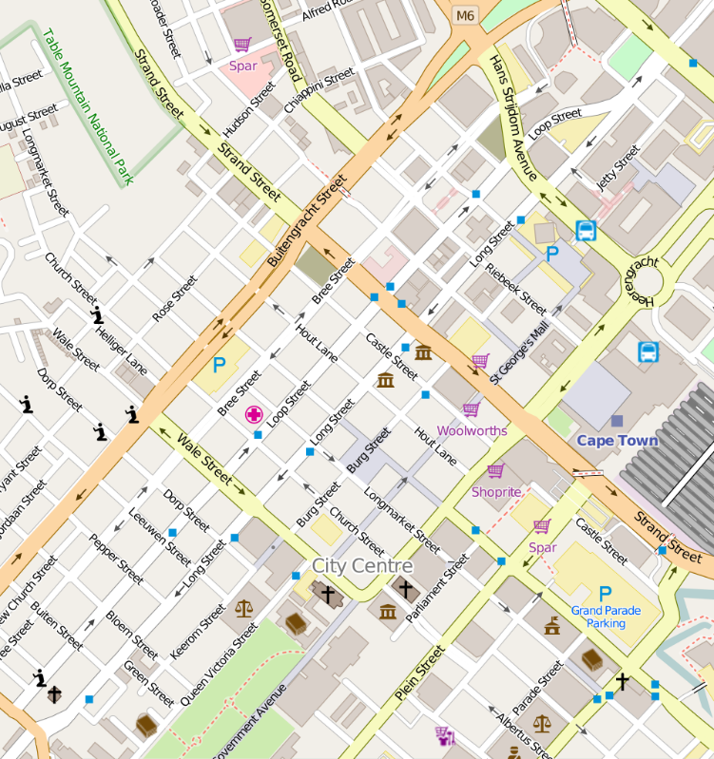

[Camera picture]

**Q15. Take a picture of the front door:**

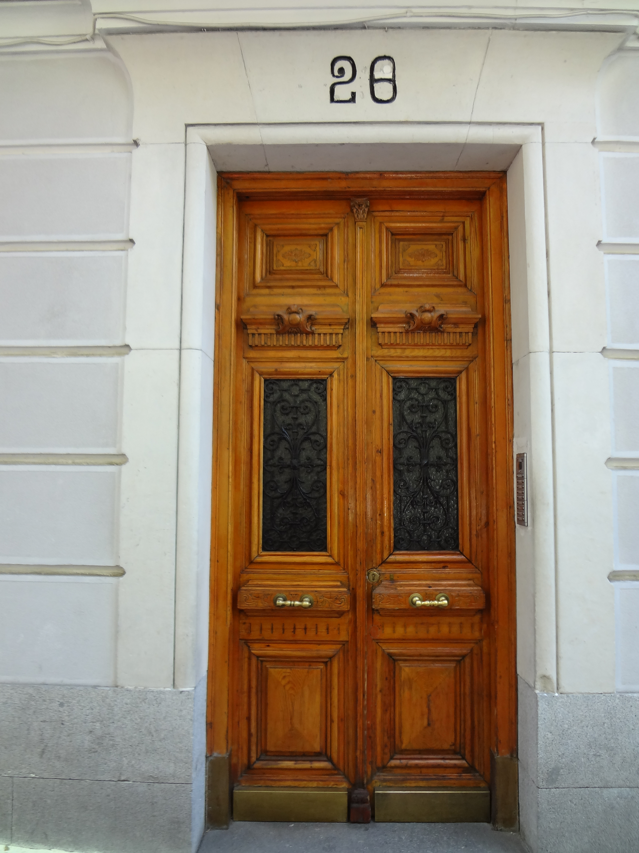

[Audio]

**Q16: Record audio:**

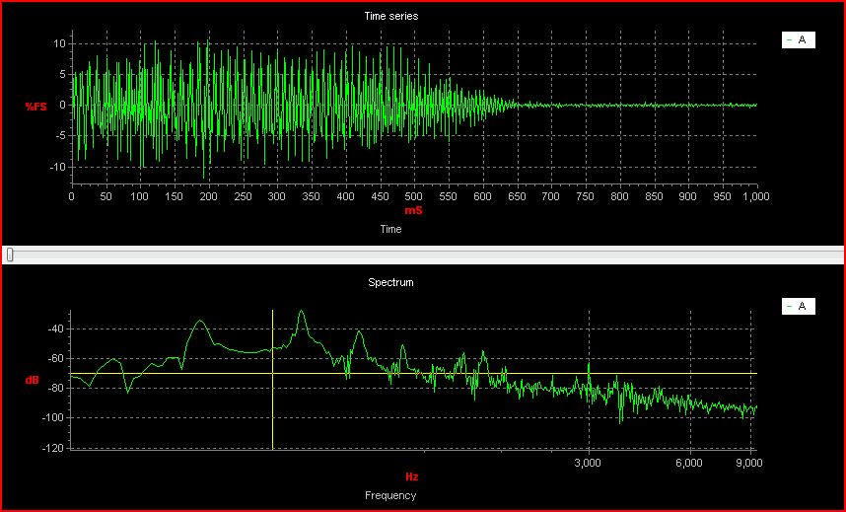

[Upload file]

**Q17 Upload a diary**



[Image Question]

**Q18: Choose an image:**

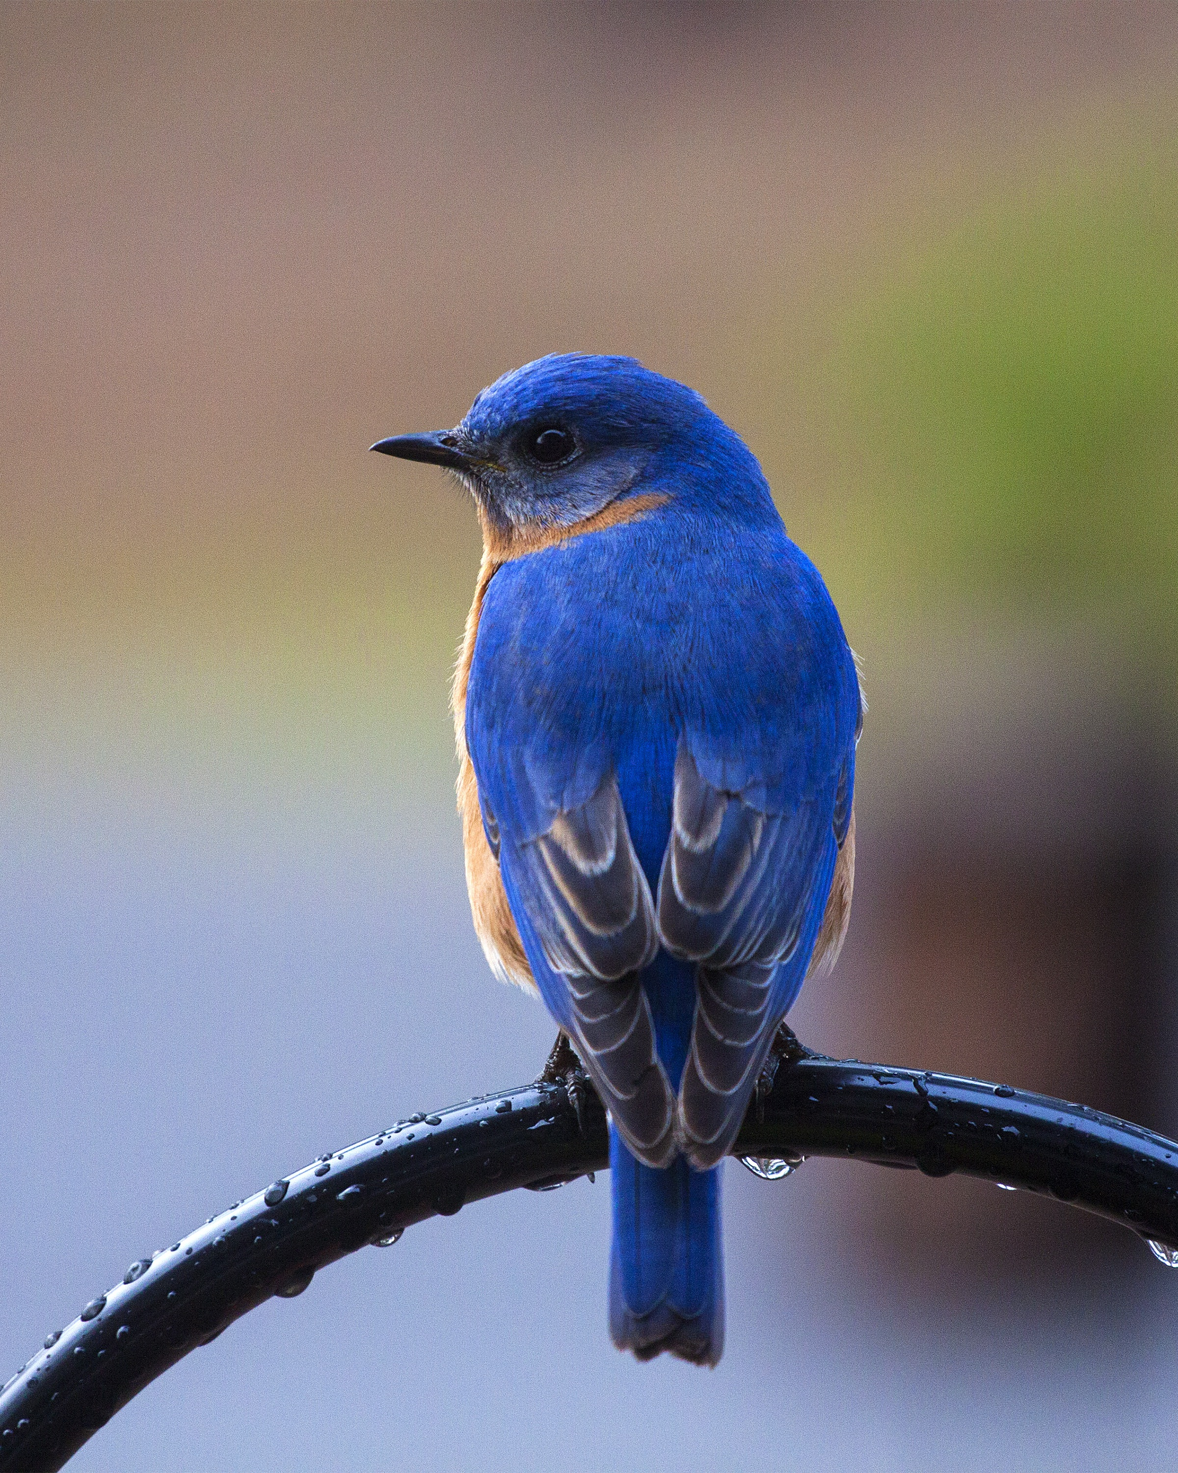 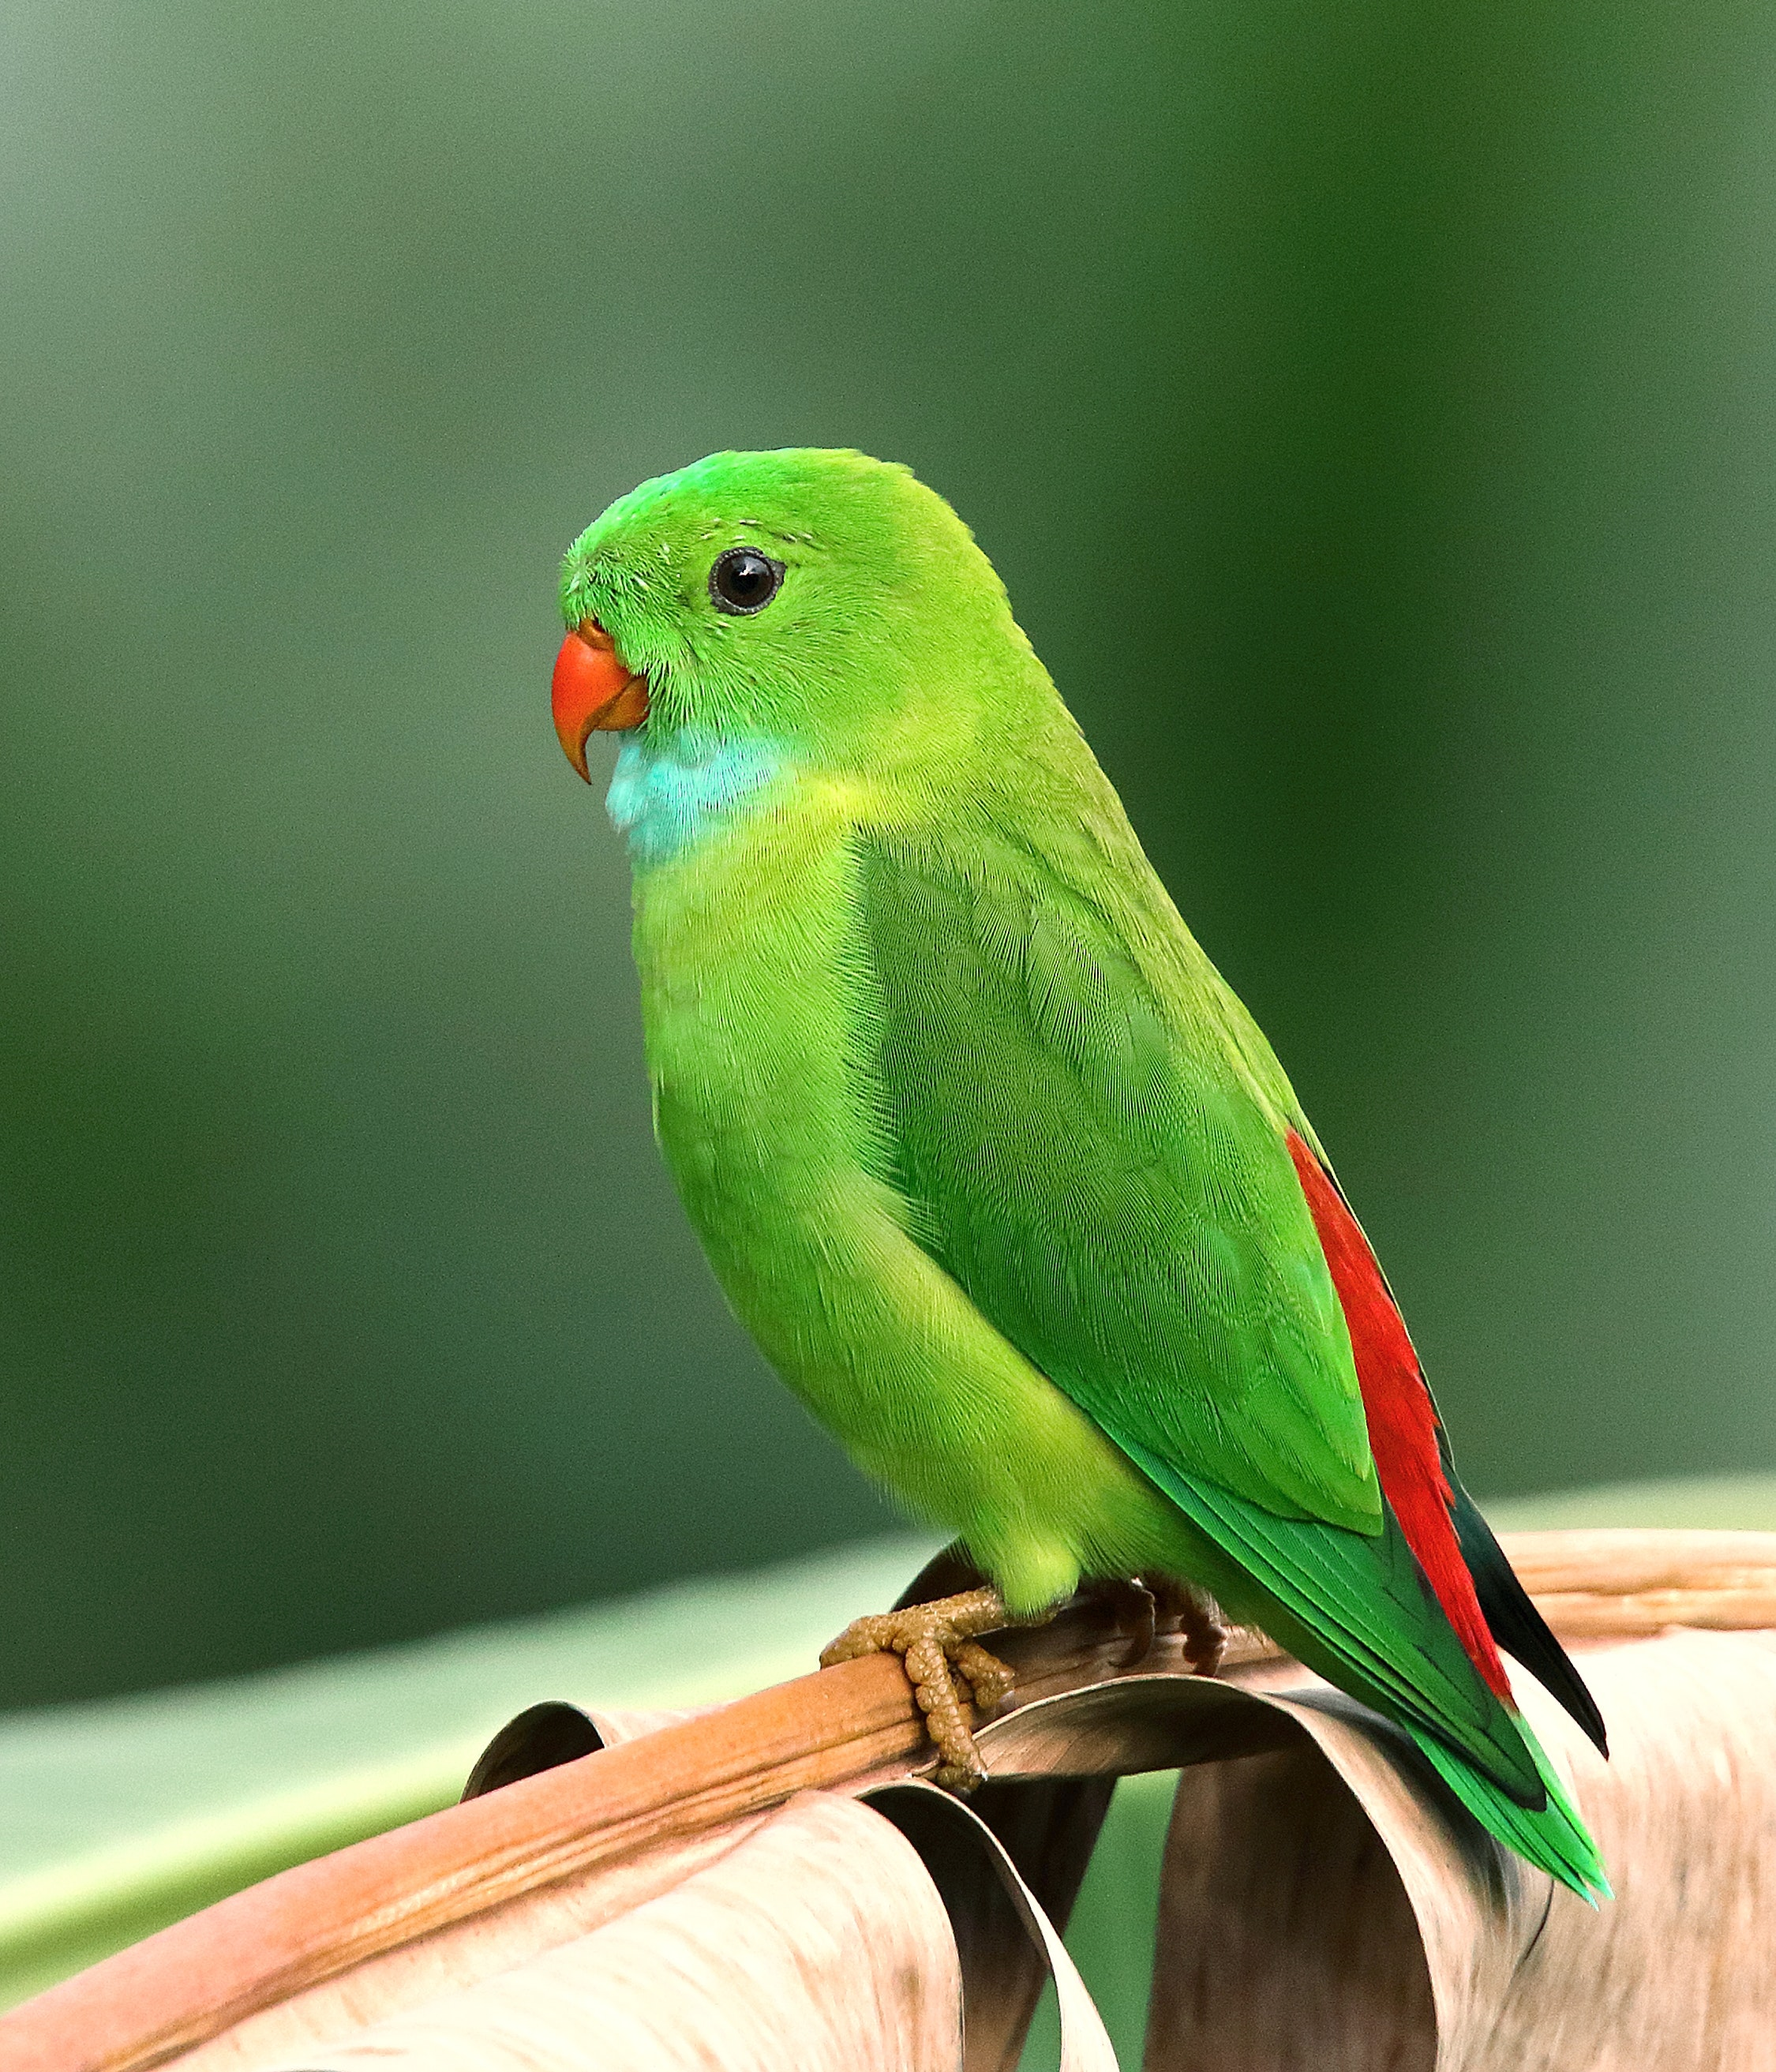 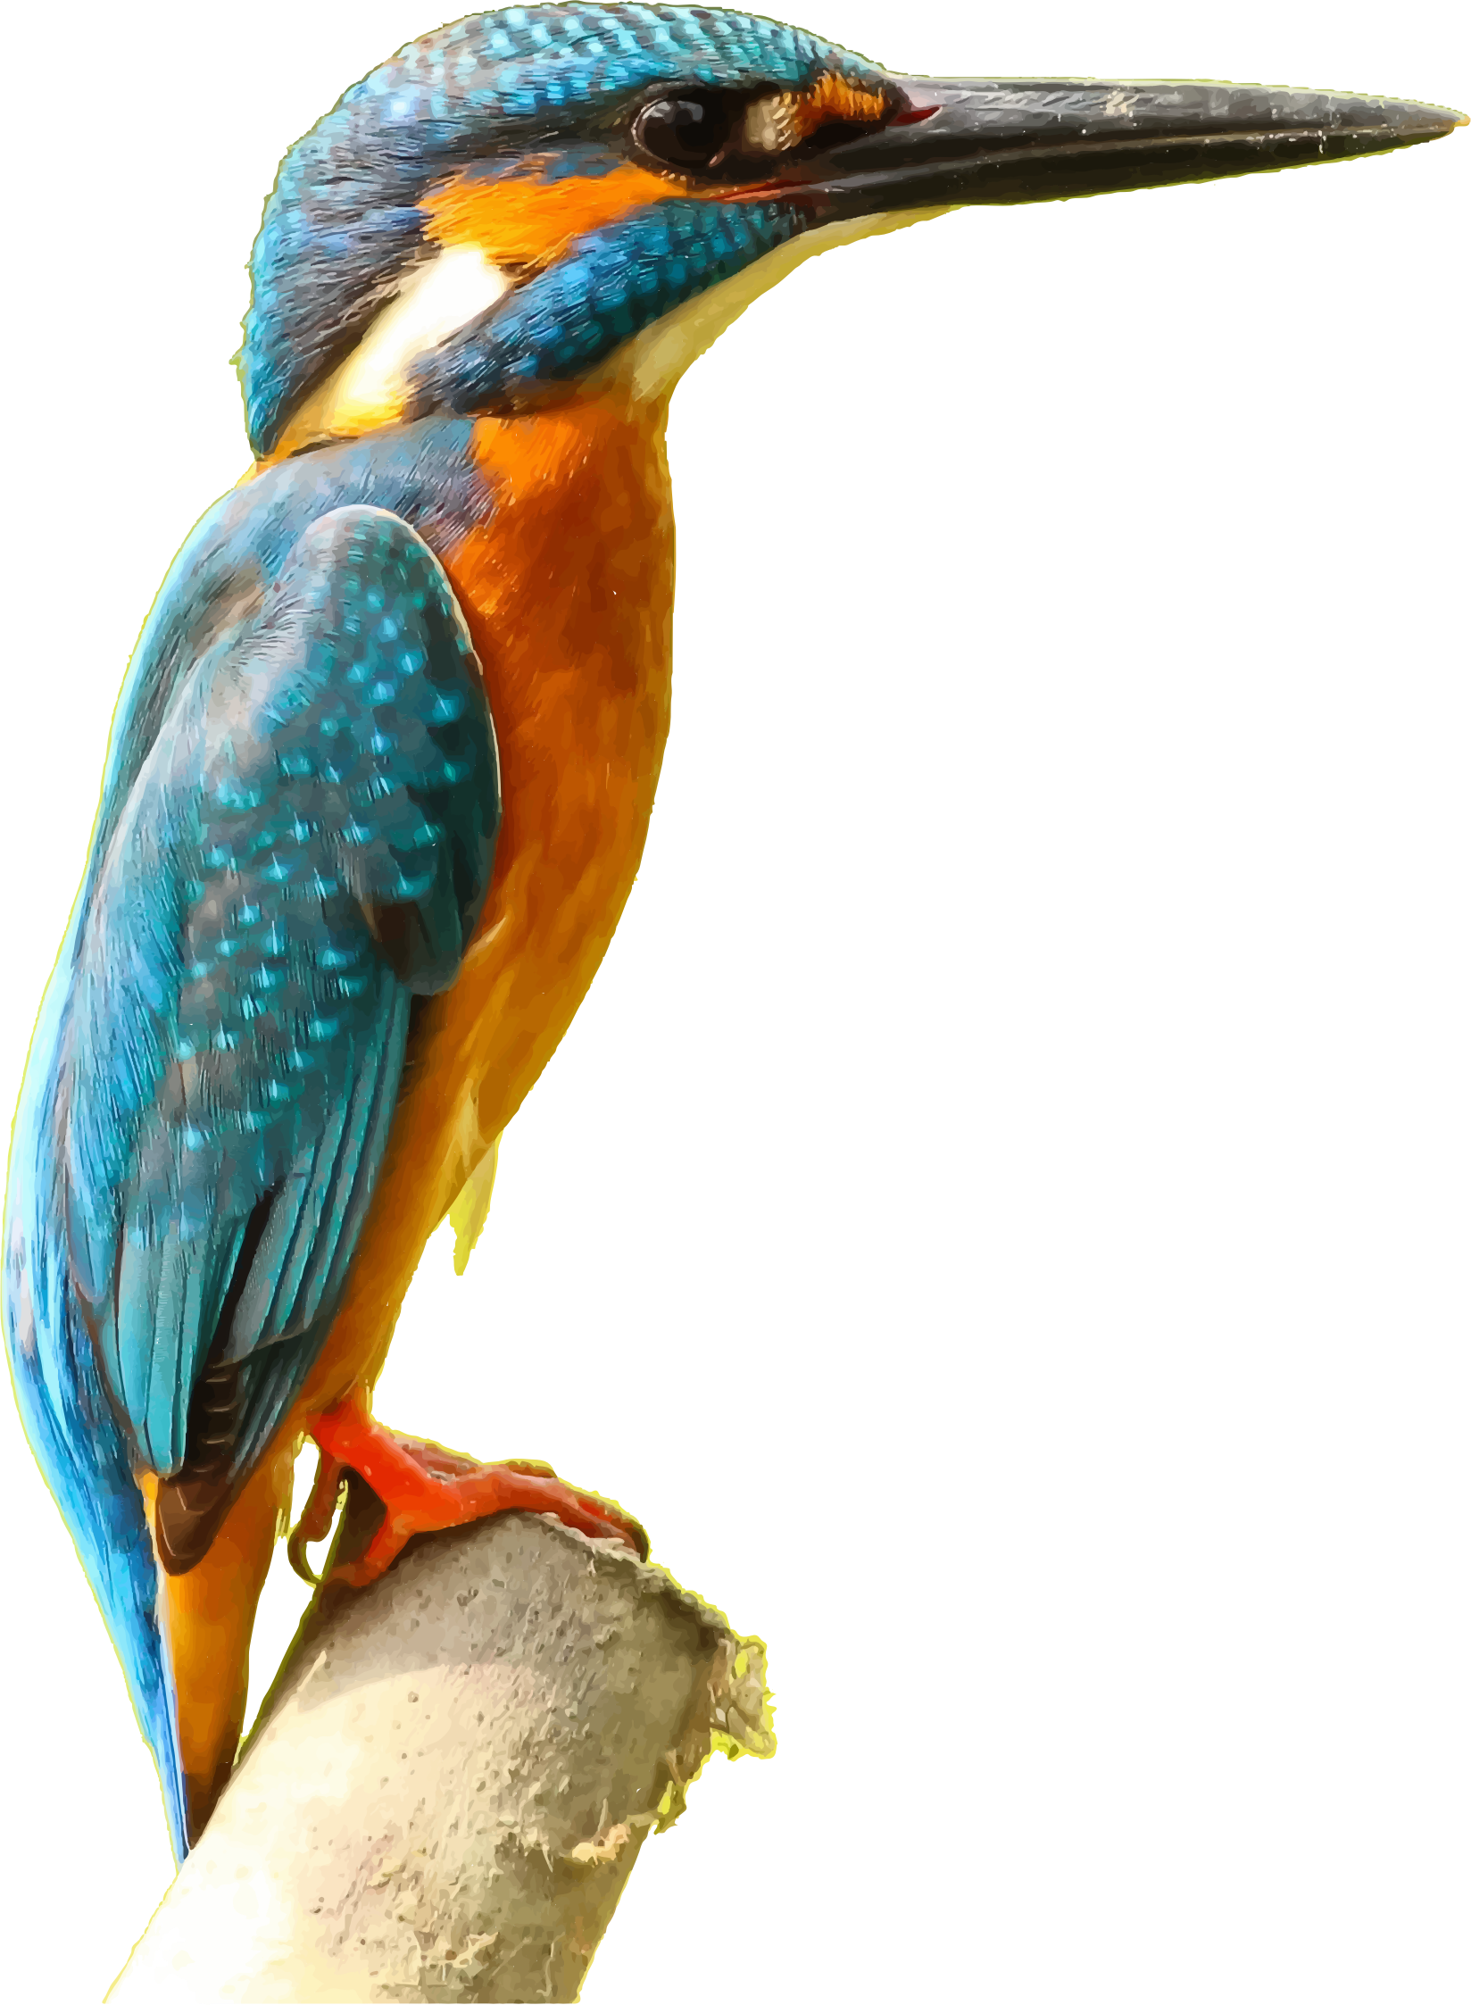

1. Code table for allowed relationship values

   |  |  |
   | --- | --- |
   | **Code** | **Relationship** |
   | 1 | Head of Household |
   | 2 | Spouse / Partner |
   | 3 | Son / Daughter |
   | 4 | Brother / Sister |
   | 5 | Father / Mother |
   | 6 | Grandfather / Grandmother |
   | 7 | Grandson / Granddaughter |
   | 8 | Other Relative |
   | 9 | Non-Relative |

  